**Android Assignment 4 (of 5)**

* This assignment is based on all you have learnt from the previous assignments and will involve the use of timers, button handlers and changing the attributes over views in a layout.

Write an application that has an initial view that looks like this below:

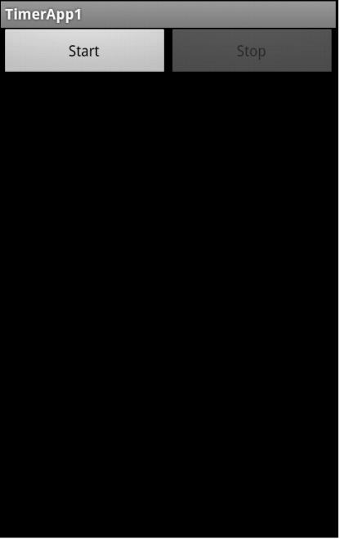

* Pressing start will start a timer that will cycle the four squares through the colours *red->yellow->green->blue* and back to *red*. Each time the timer fires, the colour sequence will move along to the next in sequence.

When it is running, your application should look something like this, with the colours alternative each time the timer fires.

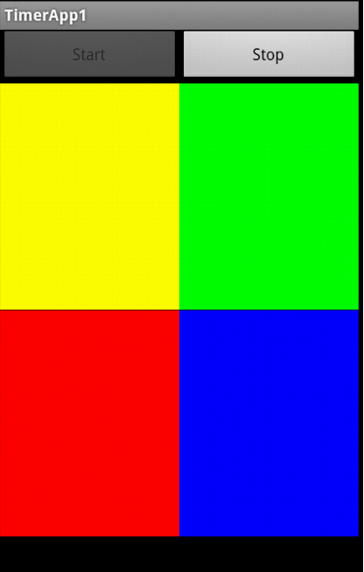

* Pressing the stop button will stop the timer and leave the colours in whatever position they are in when the stop button was pressed.
* This can continue indefinitely.
* The start and stop buttons should be disabled appropriately according:- *Start* is disabled when already playing and *Stop* is disabled when already stopped.